Institute of Management Sciences, Peshawar

Human Computer Interaction (HCI)

Semester Project – Fifth Milestone

Project Title: ShopEase – Interactive E-Commerce Shopping Platform
Program: BS (Data Science)
Semester: 7 (Group B)
Course Instructor: Mr. Hamood Ur Rehman Durrani (Assistant Professor)
Team Members:
- Hamza Shahid
- Hottam ud din

Fifth Milestone: Global and “Wider Still” Design

Part 1: Global Navigation Design

1. Hierarchical Navigation Design

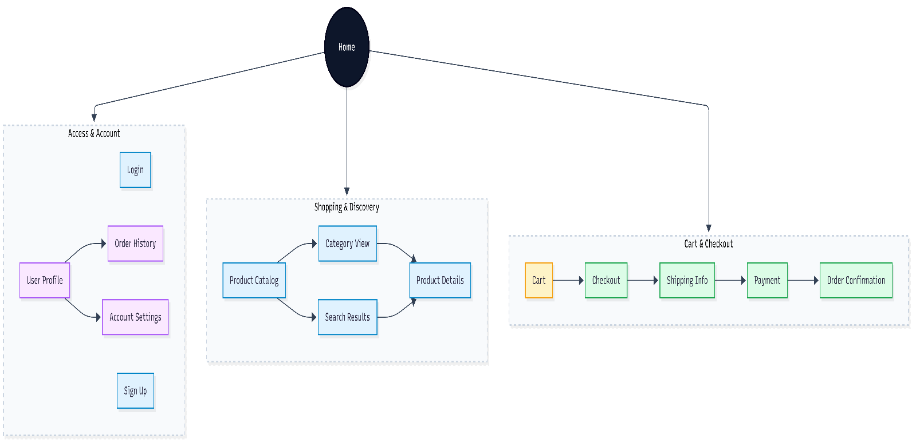

Explanation of Hierarchical Diagram

This hierarchical diagram presents the top down structure of ShopEase with Home as the root. Feature are grouped into three main modules: Access & Account, Shopping & Discovery, and Cart & Checkout. This organization keeps navigation shallow, improves learnability, and supports task-focused completion during checkout.

2. Network Navigation Design

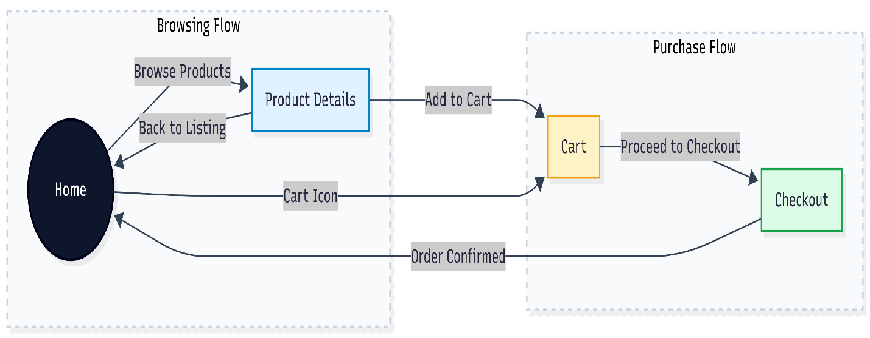

Explanation of Network Diagram
The two-lane network navigation diagram separates diagram the browsing and purchasing activities to reflect user intent. The browsing flow allows users to explore products freely, while the purchase flow provides a focused path for complete transaction. Cross-lane connections ensure flexibility without disrupting the user’s mental model, supporting usability, efficiency, and user control.

Part 2: Wider Still Design

1. Style Issues

Consistency
ShopEase follow a strict and well defined style guide to maintain visual consistency across the platform. A primary color palette (e.g., Royal Blue) is used for key action such as “Buy Now” and “Proceed to Checkout” while a secondary palette (e.g., Red) highlights destructive actions like “Remove from Cart”.

Typography
A single, highly legible sans-serif font family such as Roboto or Open Sans is used throughout the application. Font size, weight, and spacing are carefully adjusted to differentiate headings, product prices, descriptions, and auxiliary information, creating a clear visual hierarchy.

Branding
Brand consistency is ensured by placing the ShopEase logo at the top left corner on every page, aligning with standard user expectation. Common icons for cart, user profile, and search are sourced from established icon libraries such as Font Awesome or React Icons, reinforcing familiar mental models and improving learnability.

2. Functional Issues

Data Persistence
ShopEase ensures that users do not lose progress during their shopping experience. Cart data is preserved even if the browser tab is accidentally closed or refreshed. This persistence is achieved using LocalStorage or Redux persistence, which significantly reduces user frustration and cart abandonment.

Data Transfer
The system supports standard operating system interactions such as copy-paste functionality, particularly during the checkout process. This enables users to efficiently enter addresses, contact information, and payment details.

Error Prevention
To minimize user errors, ShopEase applies input constraints and validation rules. For example, quantity selectors do not allow values below one, and payment fields restrict input to numeric values only. These preventative measures reduce form submission errors and improve task success rates.

3. Navigation Issues (External & System)

Browser History Support
ShopEase fully supports browser navigation controls such as the Back and Forward buttons. When users navigate back from a Product Details page, they are returned to the exact scroll position on the Product Listing page, ensuring a smooth and uninterrupted browsing experience.

Deep Linking
Each product within ShopEase is assigned a unique url , enabling deep linking . Users can bookmark products or share links through external platforms such as social media or messaging applications. This features also support marketing and user acquisition strategies.

External Links
External links including payment gateways or social media pages are opened in new browse tabs this design decision prevents users from losing their current session and maintains continuity within the shopease application.

